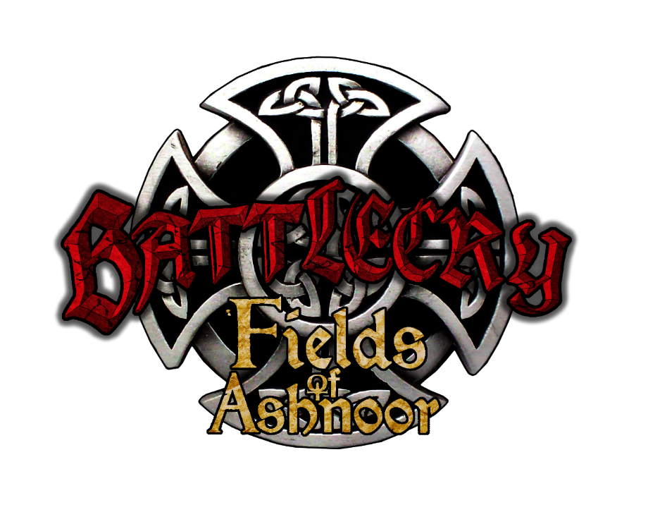

Fields of Ashnoor
Compliment, Complaint and Feedback Form

The compliment, complaint and feedback form is a tool to facilitate feedback being heard clearly and effectively. Most complaints can be resolved through a conversation between parties involved, as communication is the key to desired outcomes and resolutions of issues. Fields of Ashnoor is committed to the best possible outcome for all members, we welcome positive feedback and constructive responses. This form can assist those members wishing to inform Fields of Ashnoor Committee as a record of key information at the time of the event and beyond.

Once completed, please submit this form to: centralcoastlarp@gmail.com.au

Section 1: <INSERT NAME>
This is a: Please Indicate your response below with an X.
Complaint |  | Please complete sections 1-10
Compliment |  | Please complete section 1-5, then go to section 11.
Feedback |  | Please complete section 1-5 then go to section 13.
Are you providing feedback on another person’s behalf? [Indicate your response with an X]
yes
no | [Go to section 4]

Section 2: Feedback made on another person’s behalf.
Please provide the following details about the person on whose behalf you are acting:
First Name:
Last Name:
Relationship to another person:

Please provide details of your relationship to the person on whose behalf you are acting:
Are you a legal representative for the person who received the service? [e.g. parent or guardian of a child under 18 years but older than 16 years or guardian of an adult person – indicate your response with an X]

yes |  | If yes, please provide details:
no

Does the person know you are making a compliment, complaint or feedback on their behalf? [Indicate your response with an X]
yes
no
If no, please provide the reason why:

Section 5: Please state your concerns.
Please provide details of your main concerns, including what events took place which led to making the complaint, including reference to the code of conduct. https://fieldsofashnoor.com.au/wp-content/uploads/2023/02/Code-of-Conduct-policy-2023-1.pdf

Section 6: What action have you already taken in relation to this complaint?
Have you discussed your concerns with the person(s) involved regarding this complaint?
yes
no
If yes, with whom and what was the outcome? If, Not, why not.

Section 7: Please enter in the box below your solutions for this complaint process?

Section 8: Has the issue been resolved?
yes
no

What further steps are required for parties coming to a desired outcome?

Section 9: If the issue has not resolved, do you wish to make a formal complaint? This process may be escalated to Battlecry: Fields of Ashnoor Committee and/ or Battlecry: Age of Markoth Committee.

yes
no

Section 10: Declaration
Information provided is true and correct.
Signature: |  | Date:

Section 11: Compliment.

Please provide a summary of your compliment.

Section 12: Do you wish to recognise someone for their contribution? If yes, please provide details.
yes |  | Details:
no

Declaration: Compliment
Information provided is true and correct.
Signature: |  | Date:

Section 13: Do you wish to provide feedback to Fields of Ashnoor committee?
yes
no

Section 14. Please provide a summary of your feedback, positive or negative below. Please include background, the main reason for informing the committee and how we could improve our game using your solutions.

Summary below:

Declaration: Feedback
Information provided is true and correct.
Signature: |  | Date:

The Fields of Ashnoor committee are volunteers, we aim to respond to your feedback in a timely manner. We will process your compliment/ complaint/ feedback as soon as possible dependent on information required for decision making, level of risk to its members and your admin’s time available to respond in an effective positive way.

Thank you for your submission.

Fields of Ashnoor Committee

